Electrical safety testing

1. Scope

This code of practice builds on current industry best practice and aims to give guidance to PSE Members in relation to the electrical safety testing of their electrical hire equipment.

The code of practice is intended to apply to low voltage equipment, that is equipment operating up to 1000 V AC or 1500 V DC between conductors or 600 V AC 900 V DC between conductors and earth. It is specifically intended for single phase equipment operating at a nominal voltage of 230 V AC and where applicable reduced low-voltage equipment operating at 110 V AC. The measures contained within this code of practice also apply to direct current (DC) equipment, where this equipment is judged by the PSE Member to represent a danger to safety.

While the principles of this code of practice apply to all electrical hire equipment, specific attention has been paid to hot wash units, welfare units and luxury trailer units , which represent the majority of electrical hire equipment available from PSE Members.

2. Electrical Hire Equipment

It is the responsibility of all PSE Members to ensure the safety of the equipment they hire, where this equipment also incorporates electricity it is essential that the safety of this equipment is verified by competent persons at intervals sufficient to avoid danger and where necessary maintenance carried out, records of these activities must be kept throughout the working life of the equipment.

All equipment placed on hire by PSE Members must be of proper construction, it must comply with all applicable standards, taking full account of the nature of the environment in which the equipment will be used by the client. Typical examples of applicable standards are; British and European standards, CE marking and Manufacturer's instructions.

Where equipment is constructed, modified or adapted by the PSE Member, the PSE Member must be able to demonstrate that their design complies with all applicable standards, that proper materials have been used and that the work has been carried out by competent persons. Before being placed into service the equipment must be subjected to inspection and testing to verify that all requirements have been met, the records of inspection and testing should be kept for the working life of the equipment.

Each PSE Member must maintain a register of all electrical hire equipment to enable regular inspection, testing and maintenance to be managed at appropriate intervals.

3. Procedures for inspection, testing and maintenance

Hot Wash Units

Due to the comparative simplicity of hot wash units, inspection and testing will usually be carried out in-house by the PSE Member. Competent persons will perform a series of inspections and tests based on the items listed in paragraph 3.4 of this code of practice.

Welfare and Luxury Trailer Units

It will not be possible for most PSE Members to fully test this type of equipment in-house, therefore it is recommended that this type of equipment is inspected and tested at least annually by a third party company in accordance with paragraph 3.5 of this code of practice.

In addition to the annual third-party inspection and testing the PSE Member shall carry out in-house pre-hire, on-hire and post-hire inspection and testing, to confirm the ongoing safety of the equipment between annual inspections and tests. The exact contents of the in-house inspection and testing should be determined by a competent person, but will typically include; a visual inspection of the unit, PAT testing of any appliances such as kettles or microwaves, RCD testing and functional testing.

3.1 Pre-hire

Before equipment is placed on hire with a client, it is the duty of the PSE Member to ensure that the equipment is safe, therefore it will be necessary to carry out inspection and testing to verify the electrical safety of the equipment before each hire. Records of inspection and testing will be kept and a label will be affixed to the equipment stating the date on which inspection and testing was carried out.

3.2 On-hire (During the hire period)

When equipment is placed 'on-hire' with the client, i.e. the hire period has commenced, responsibility for the ongoing safety of equipment passes to the client.

The client is responsible for:

- The safety of the supply provided to the hire equipment.
- Confirming the safety of the equipment after delivery, placement on the client's site and connection to the supply.
- Performing a risk assessment on the equipment.
- Any ongoing inspection and testing required during the hire period.

The client should perform a risk assessment to determine any control measures necessary to ensure the safety of the equipment during the hire period. As a result of the risk assessment carried out by the client, the client may decide to subject the hire equipment to inspection and testing at an interval which is less than the hire period.

Inspection and testing during the hire period may be carried out by the client or the client may decide to ask the PSE Member to perform this service on their behalf. Where it is agreed that the PSE Member will carry out inspection and testing during the hire period it is reasonable that the client is charged for this service.

3.3 Post-hire

When hire equipment is returned to the PSE member company, following a period of hire with a client, the safety status of that equipment must be considered 'unknown' and potentially dangerous, until such time as inspection and testing have been carried out and the safety status is determined. If at the time of inspection and testing defects are found which give rise to danger the equipment must be quarantined and clearly labelled, with a fail label, making all staff aware that this equipment must not be used until maintenance has been carried out and equipment has been retested.

Where the turnaround time between hires is sufficiently short, 'post-hire' and 'pre-hire' safety testing may be amalgamated into one process.

3.4 In-House inspection and testing

To confirm the safety of hire equipment and identify if maintenance is required, the PSE Member must carry out inspection and testing of the hire equipment.

Inspection and testing will typically include:

- A visual inspection
- Earth continuity testing (class I equipment only)
- Insulation resistance testing
- Protective conductor or touch current testing (Where appropriate)
- RCD testing (Where appropriate)
- A functional check

Further guidance on inspection and testing can be found in the IET code of practice for in-service inspection and testing of electrical equipment.

3.5 Third-party inspection and testing

Where the complexity of the hire equipment precludes inspection and testing being carried out in-house by the PSE Member, as will usually be the case for 'welfare' and 'Luxury' units, it is strongly recommended that inspection and testing be carried out by a third party, annually or at an interval specified by the PSE Member following a risk assessment.

Third-party inspection and testing shall only be carried out by electrical contracting companies registered with a recognised industry body, such as NICEIC, ECA or NAPIT. The electrical contracting company should be approved by their registration body, within the scope of their membership, to carry out the type of work undertaken. Formal certification must be issued for all inspection and testing carried out by third parties and the preferred form of the certification is the NICEIC transportable building periodic inspection report or a similar form provided by another body.

4. Training

All persons carrying out inspection, testing and maintenance on behalf of a PSE Member shall be competent to do so. It is the responsibility of each PSE Member to ensure the competency of those they employ. In order to be deemed competent each person must have sufficient knowledge and experience to avoid danger to themselves and others.

It is expected that PSE Members will hold a register of competent persons with a list of activities that each person is competent to carry out, furthermore the PSE Member will hold a training file for each employee containing evidence of both training and experience.

It is further recommended that employees keep their training up-to-date by attending a refresher course at intervals of no greater than every three years.

5. Test equipment
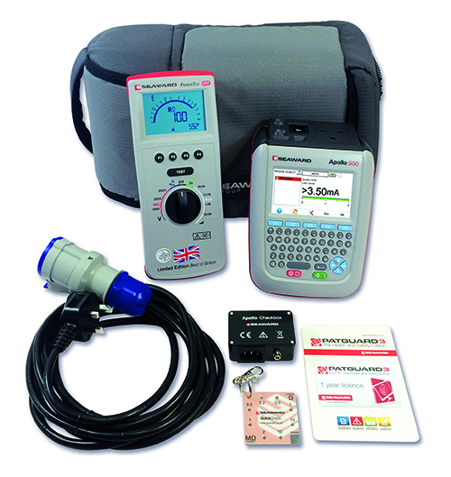
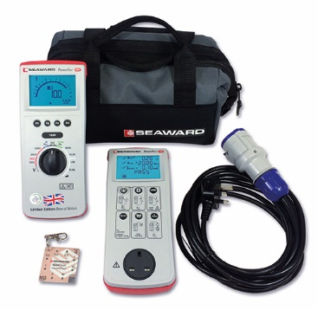

PROFESSIONAL KIT
MANUAL KIT

In order to carry out electrical testing suitable test equipment will be required. All test equipment used by PSE Members must comply with the appropriate product standards, be of sound construction and in good working order. Test equipment should be subject to at least annual calibration by a recognised calibration company, records of calibration should be kept throughout the working life of the test equipment.

In addition to formal calibration PSE Members must carry out regular inspection and verification of the test equipment using a proprietary checkbox or similar, these records should also be kept throughout the working life of the test equipment.

